EXCELERATE CONNECT
Mobile App Development with Flutter — Virtual Internship
Week 1 Deliverable: App Proposal, Wireframes & Navigation Flow, and GitHub Repository Setup
Team: | SLU 0607 MAD Team 7
Program:  Version: | Mobile App Development with Flutter Internship  1.1
Submission Window: | Jul 4, 2026 – Jul 13, 2026

1. App Proposal Document

1.1 App Overview
App Name: Excelerate Connect
Excelerate Connect is a mobile application built with Flutter that brings Excelerate's virtual internship and learning-program ecosystem into a single, easy-to-use mobile experience. The app allows learners to discover, apply for, and track global internships, courses, and competitions, while giving administrators a lightweight way to publish and manage program content and monitor learner engagement.

1.2 Purpose of the App
The purpose of Excelerate Connect is to close the gap between learners looking for real-world career experience and the organizations offering it. The app centralizes program discovery, application, and progress tracking so that learners no longer have to rely on email threads or scattered web pages, and it gives program administrators a simple mobile-friendly panel to keep listings current.
Core goals of the app:
- Make it fast and simple for learners to find internships and programs that match their interests and skill level.
- Provide a transparent, step-by-step application and onboarding journey.
- Give administrators an efficient way to publish, edit, and retire program listings.
- Keep learners informed of deadlines, deliverables, and progress through notifications and a personal dashboard.

1.3 Target Users

Learners (Primary Users)
Students and early-career professionals who want to build practical skills through virtual internships, courses, and competitions. They need to browse opportunities, understand requirements at a glance, apply quickly, and track their progress once enrolled.

Administrators / Program Coordinators (Secondary Users)
Excelerate staff or partner organization coordinators who create and maintain program listings, review learner submissions, and monitor engagement metrics across programs.

1.4 Key Features

Learner-Facing Features
- Secure sign-up / login with email or social account.
- Personalized home feed with recommended and trending programs.
- Searchable, filterable program listing (by category, duration, skill level, and start date).
- Detailed program page with description, weekly deliverables, mentor info, and an Apply button.
- One-tap enrollment / application flow with confirmation.
- Personal dashboard showing enrolled programs, deadlines, and submission status.
- Push notifications for new opportunities, deadlines, and feedback.
- Editable profile with skills, resume link, and certificates earned.
- Feedback Form to rate a program and leave comments for admins to review.

Admin-Facing Features
- Admin login with role-based access.
- Create, edit, publish, and archive program listings.
- View learner applications and submission status per program.
- Basic engagement analytics (views, applications, completion rate).
- Review learner feedback and ratings submitted per program.

1.5 User Journey Examples

Learner Journey — Applying to a Program
- Learner opens the app and logs in from the Login screen.
- Learner lands on the Home screen and sees recommended programs.
- Learner taps “View All” to open the Program Listing screen and filters by “Mobile Development.”
- Learner selects the Flutter Internship card to open Program Details.
- Learner reviews deliverables and mentor details, then taps “Apply Now.”
- Learner receives an in-app confirmation and the program appears on their Profile / Dashboard under “Ongoing Programs.”

Admin Journey — Publishing a New Program
- Admin logs in and is routed to the Admin Dashboard.
- Admin taps “Add New Program” and fills in title, description, duration, and weekly deliverables.
- Admin uploads a cover image and publishes the listing.
- The new program instantly appears on learners' Home and Program Listing screens.
- Admin monitors applications and engagement from the dashboard as learners apply.

2. Wireframe Designs
The wireframes below are low-fidelity mockups of the core screens of Excelerate Connect: Login, Home, Program Listing, Program Details / Profile, and Feedback Form. They focus on layout and structure — placement of navigation bars, buttons, text areas, and forms — rather than colors or final styling, in line with early-stage UX design practice.

2.1 Login Screen
Login Screen — Wireframe

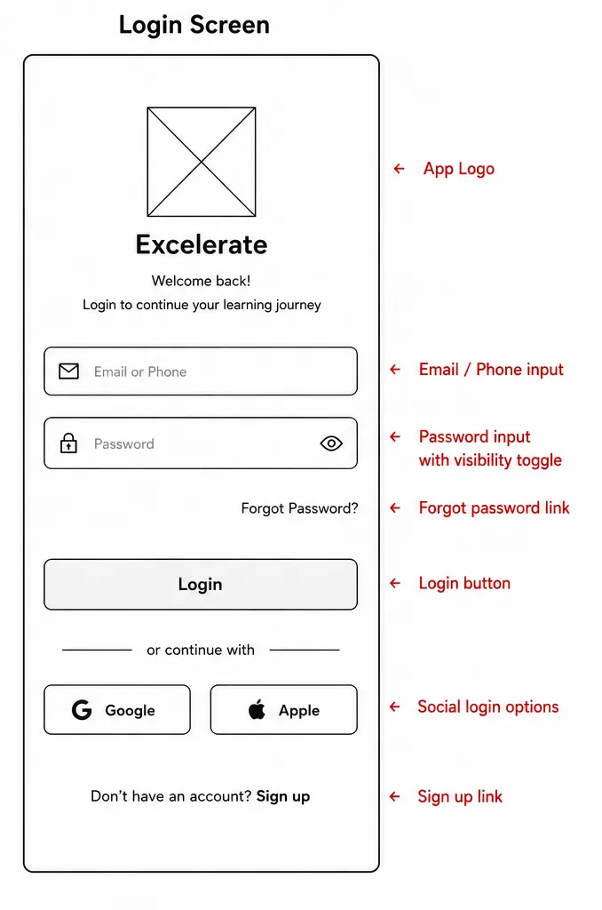
Purpose: authenticate learners/admins and route them to the correct home screen (learner Home vs. Admin Dashboard) based on role.

2.2 Home Screen
Home Screen — Wireframe

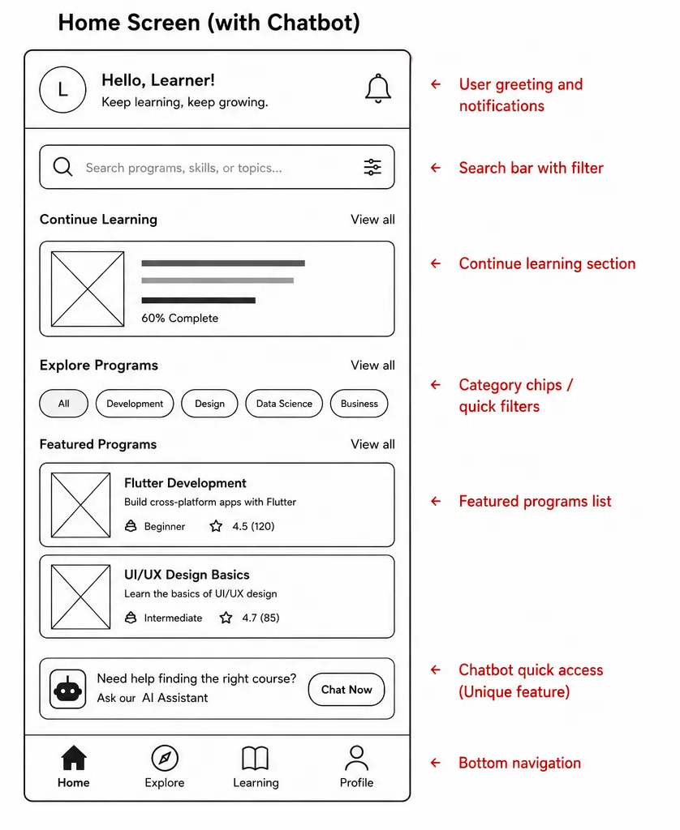

Purpose: give learners quick access to search, recommended/trending programs, and the bottom navigation bar used across the app.

2.3 Program Listing Screen
Program Listing Screen — Wireframe

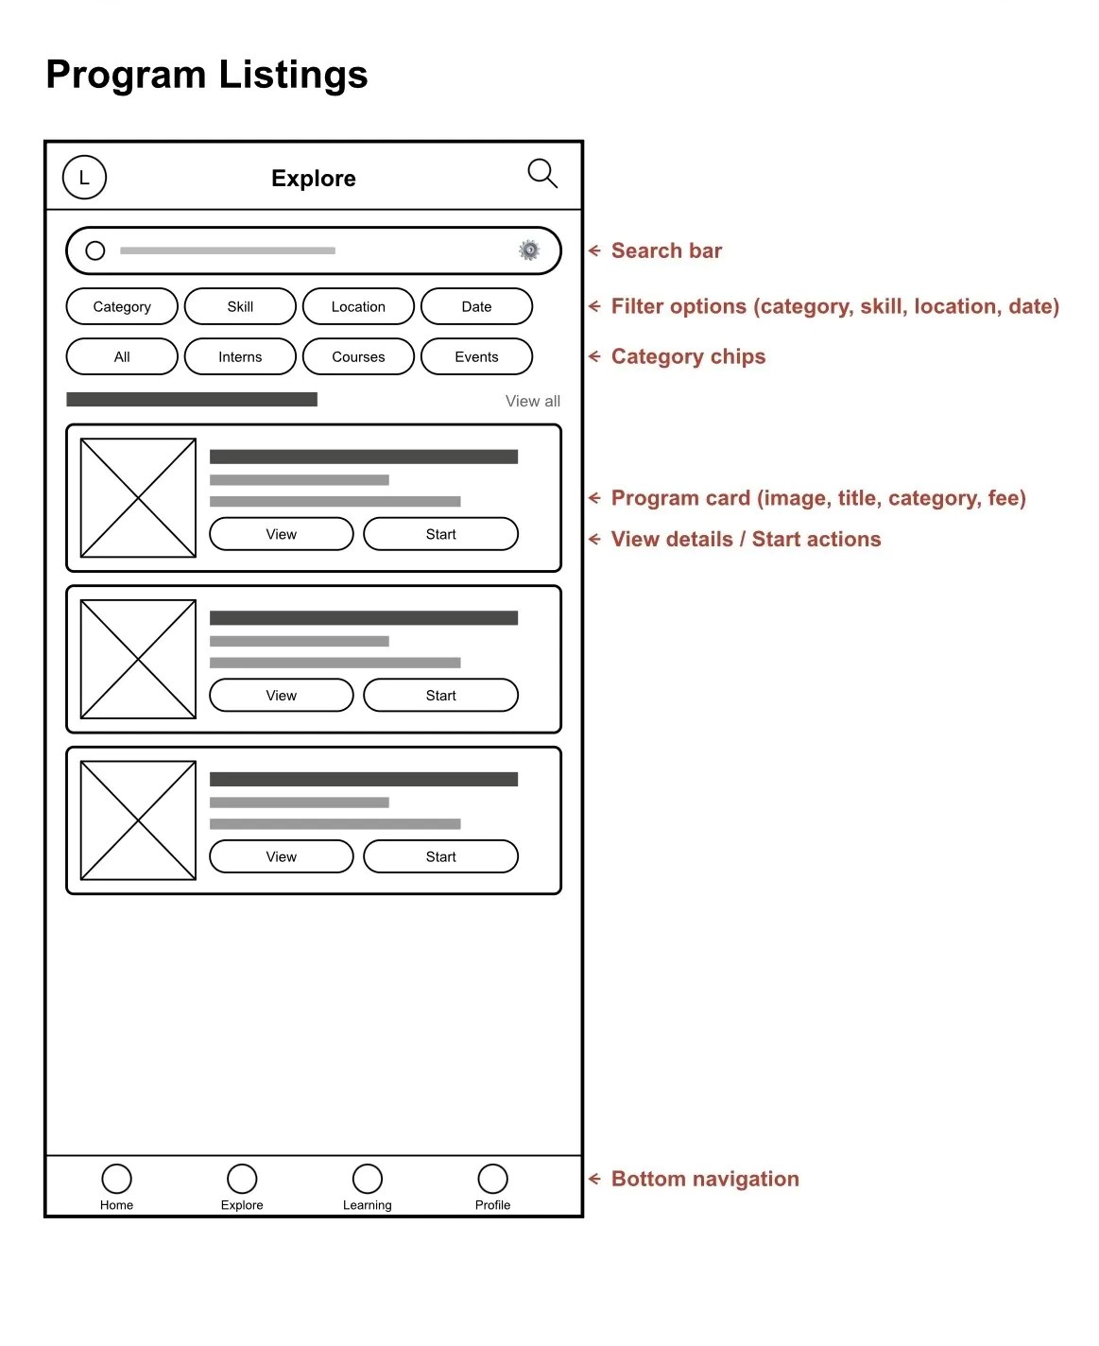

Purpose: let learners browse, filter, and sort all available programs before drilling into details.

2.4 Program Details / Profile Screen

Program Details Screen — Wireframe

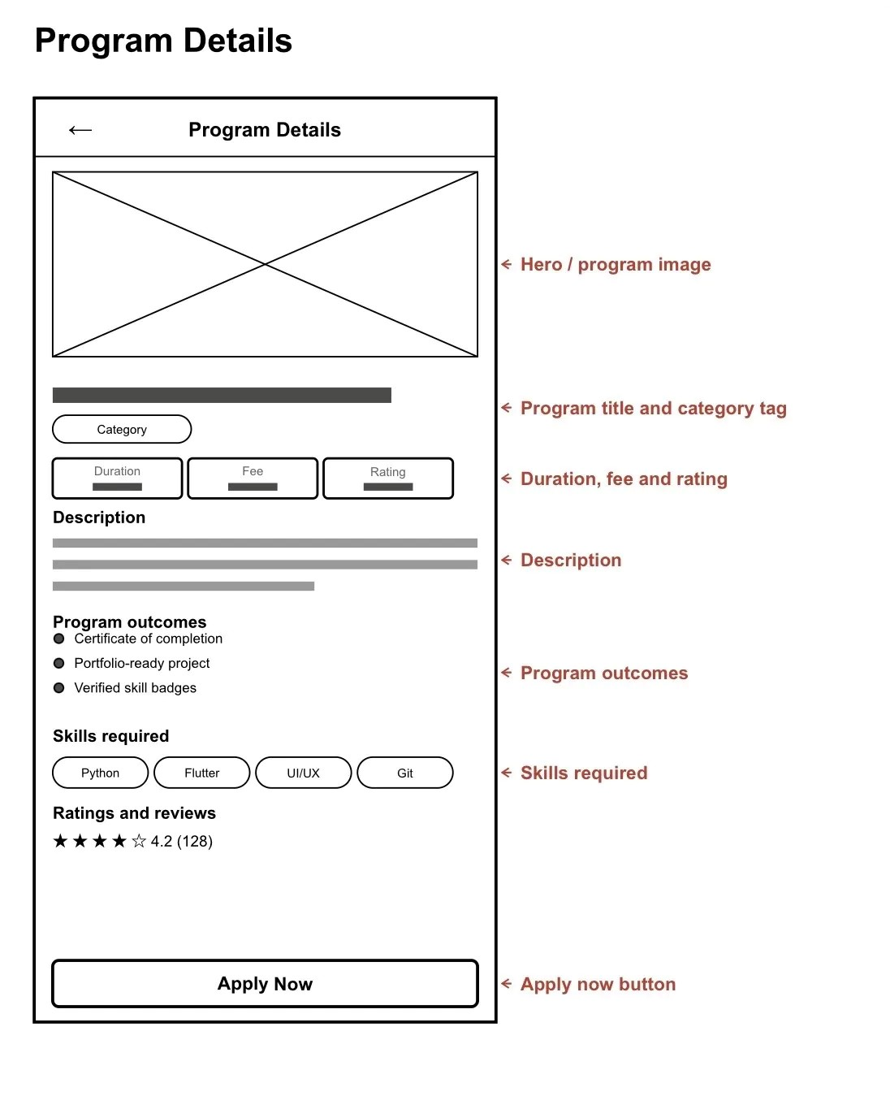

Profile Screen — Wireframe

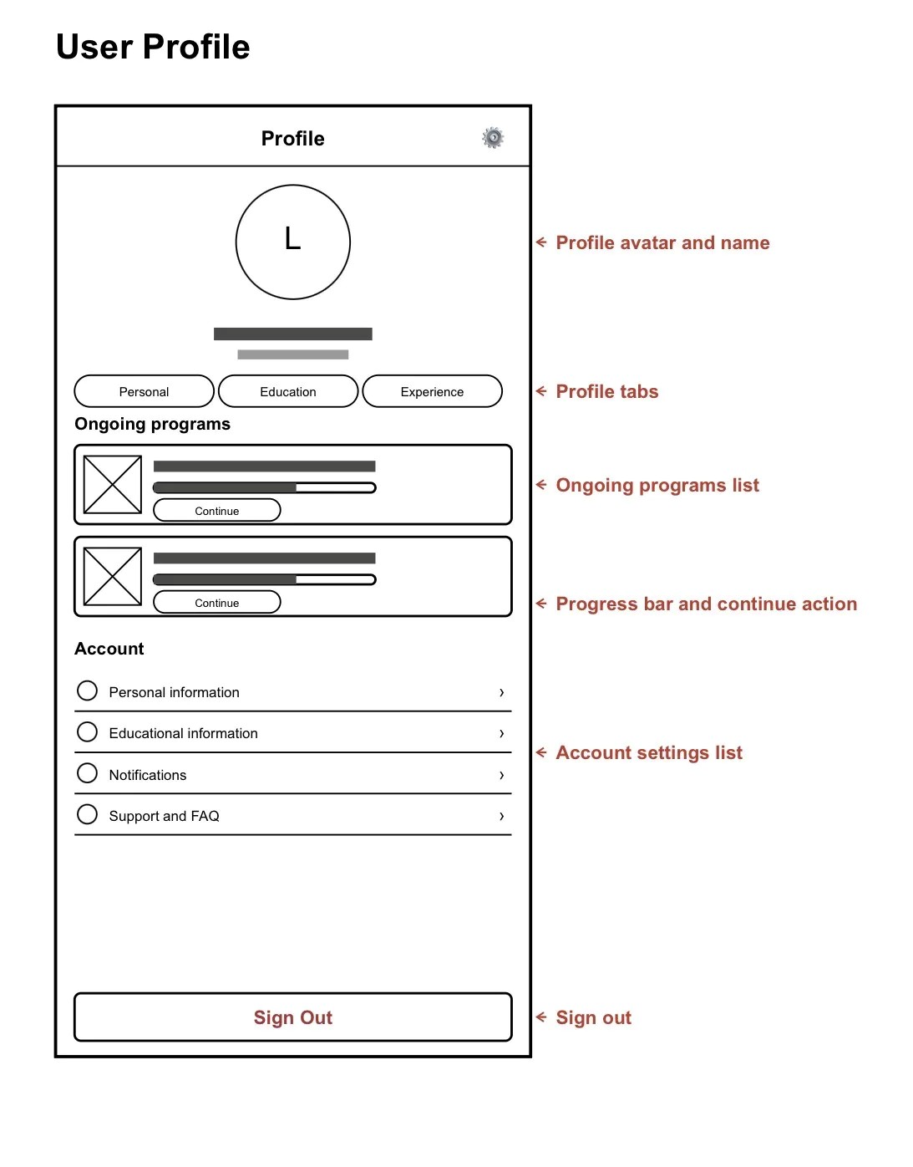

Purpose: Program Details converts an interested learner into an applicant; Profile lets a learner track ongoing programs, certificates, and personal information.

2.6 Navigation Flow
The primary navigation path connects the core screens, with a persistent bottom navigation bar (Home / Programs / Alerts / Profile) once a learner is logged in:
Login → Home → Program Listing → Program Details → Apply Now → Confirmation → Profile (Ongoing Programs) → Feedback Form
Admin side: Login → Admin Dashboard → Manage Programs → Review Feedback (per program)
Every screen below Home retains access back to Home via the bottom navigation bar, so there are no dead ends in the flow.

Screen Hierarchy
- Home (parent)
  - Program Listing (child of Home)
  - Program Details (child of Program Listing)
  - Feedback Form (child of Program Details, shown after/around program completion)
- Profile (parent, reachable from bottom nav on any screen)
  - Ongoing Program tracker (child of Profile)
- Admin Dashboard (parent, admin role only)
  - Review Feedback (child of Admin Dashboard, per program)
Wireframing tool used: layouts above were structured for direct build-out in Figma (recommended for team collaboration and shareable prototype links).
3. GitHub Repository Setup

3.1 Repository Information
Repository name: excelerate_connect
Visibility: public
Repository URL: https://github.com/KrishTrivedi025/excelerate_connect

3.2 Initial Flutter Project Folder Structure
excelerate_connect /
├── lib/
│ ├── screens/ # UI screens (Login, Home, Program Listing, etc.)
│ ├── widgets/ # Reusable UI components
│ ├── models/ # Data models
│ └── services/ # API / data handling
├── android/ # Android platform files
├── ios/ # iOS platform files
├── pubspec.yaml # Dependencies & project metadata
└── README.md

3.3 README.md Content

Project Vision
Excelerate Connect aims to make discovering and completing virtual internships and learning programs as simple as browsing a marketplace — helping learners build real career experience and giving administrators an efficient way to publish and manage opportunities, all from a mobile device.

Objectives
- Build a cross-platform (iOS/Android) Flutter application for the Excelerate learner and admin experience.
- Deliver a clean, low-friction application flow from discovery to enrollment.
- Establish a modular codebase (screens / widgets / models / services) that scales through Weeks 2–4 of the internship.

Navigation Flow (from README)
Login → Home → Program Listing → Program Details → Apply → Profile / Dashboard → Feedback Form, with a persistent bottom navigation bar for Home, Programs, Alerts, and Profile. Admin: Login → Admin Dashboard → Manage Programs → Review Feedback.

Tech Stack
- Flutter & Dart
- Figma (wireframes & UI design)
- Git & GitHub (version control)

3.4 Version Control Evidence
Initial commit checklist to complete on GitHub before submission:
- Run flutter create excelerate_connect to scaffold the project locally.
- git init, then git add . and git commit -m "Initial commit".
- Create the GitHub repository and push with git remote add origin https://github.com/KrishTrivedi025/excelerate_connect followed by git push -u origin main.
- Add and commit README.md separately if not included in the first commit, e.g. git commit -m "Updated README with project vision and navigation flow".
- Take a screenshot of the commit history / repository page and attach it to the final submission along with the repository link.

Screenshots of the commit history

